## horizontal line

Introduction to linux

04/02/2019

Sachin kumar maurya

To The New

Exercise : 1

Question 1: Create a directory "exercise" inside your home directory and create nested(dir1/dir2/dir3) directory structure inside "exercise" with single command.

Ans: By using “mkdir” (make directory)command we can create a new directory.in case the directory is already exists with same name ,it will return an error message ‘cannot create folder, folder already exists.’

The syntax used for mkdir command is:

Syntax: *$mkdir -p/dir1/dir2/dir3.*

To create home directory and its nested directory using single command we use following syntax:

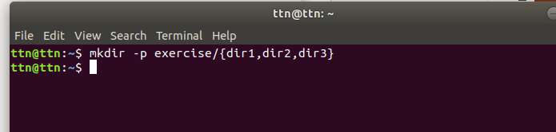

Question 2: Create two empty files inside dir2 directory: emptyFile 1,emptyFile 2 in single command.

Ans: To creates the file “touch” command is used.if the file already exists it will update the timestamp and not the contents of file.

The syntax of ‘touch’ command is :

Syntax: *$touch file_name1 file_name2.*

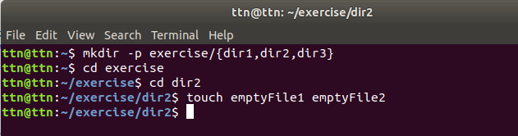

Question 3: Create one file file1.txt containing text "hello world" and save it.

Ans: firstly to create file we use touch command.now to edit file vi editor is used.

When file is opened in editor mode press *i* to go into input mode.in this mode we writes in file .and to become out of this mode press Esc.

And to save what we type :wq .

Now the file become write and quit from editor mode. 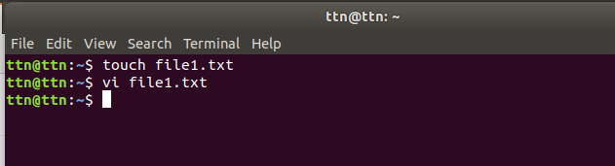

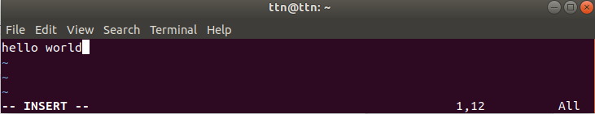

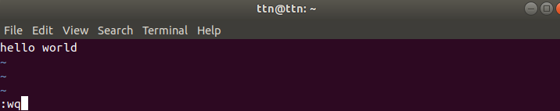

Question 4: Find a "passwd" file using find command inside /etc. copy this files as passwd_copy and then rename this file as passwd_backup.

Ans: Here *cp* command is used to copy file from one location to other location and *mv* command is used to rename file_name.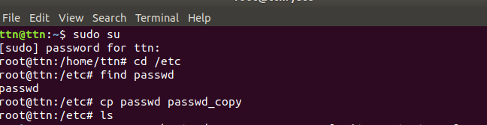

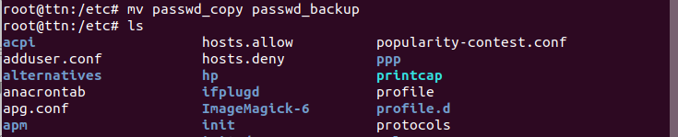

Question 5: Try reading passwd_backup file in multiple tools: less,more,cat,strings etc and find the difference in their usage.

Ans:

**more** : using more we can view a text file one page at a time,and press spacebar to go to the next page.

Syntax: *more filename*

We can also use following command:

**more -num filename** : it will show the few lines of document page as specified by num.

example : *more -10 filename* will show 10 lines for every page.

**less** : less command is much the same as more command but here You can navigate the page up/down using the less command and not possible in more command.

Syntax:  *less filename*

**cat** :cat can be used to join multiple files together and print the result on screen .

Syntax:

*cat 01.txt -* usedto display the contents of file 01.txt

*cat 01.txt 02.txt -* used to display the contents of both files

*cat file1.txt file2.txt > file3.txt* – Reads file1.txt and file2.txt and combines those files to make file3.txt.

*cat note5 >> notes* – attach note5 to notes

*cat >> file1* – add additional data in file1

**String:** The strings command returns each string of printable characters in files. Its main uses are to determine the contents of and to extract text from binary files (i.e., non-text files).

Syntax:

String filename

Question 6:Find out the number of line in password_backup containing "/bin/false".

Ans: The *grep command* stands for “global regular expression print,” processes text line by line and prints any lines which match with specified pattern. The **grep command** is used to search text or searches the given file for lines containing a match to the given strings or words.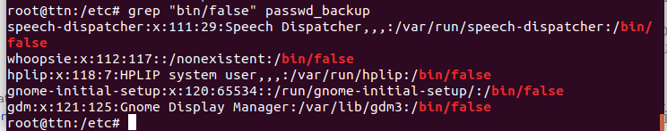

Question 7:Get the first 5 lines of a file “password_backup” and Redirect the output of the above commands into file "output".

Ans: here head command is used to print the first five line of the file . the syntax of head command is :

Syntax: *Head -num file_name*

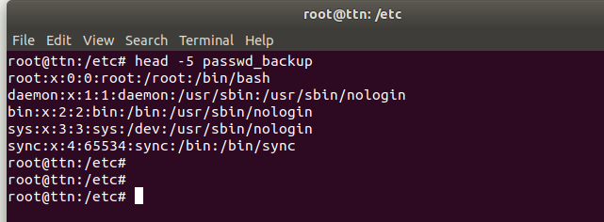

in the above image ‘>’ is used to redirect the output of command into a file.

Question 8: Create a "test" user,create its password and find out its uid and gid.

Ans : To create a user useradd command is used.and to set his password passwd command is used.and to find the uid and gid id command is used.

Syntax:*Useradd username -*to set user name.

*Passwd username* - to set user password.

*Id username* - to find uid and gid of user.

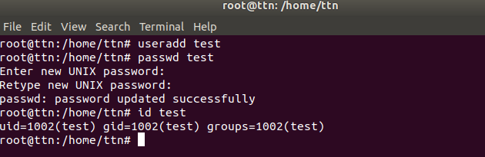

Question 9: Change the timestamp of emptyFile1,emptyFile2 which are exist in dir2.

Ans:To creates the file “touch” command is used.if the file already exists it will update the timestamp and not the contents of file.

The syntax of ‘touch’ command is :

*$touch file_name1 file_name2.*

Here in image firstly old file is shown using ll command.after that touch command is used.since file is already exist so it’s timestamp changed.

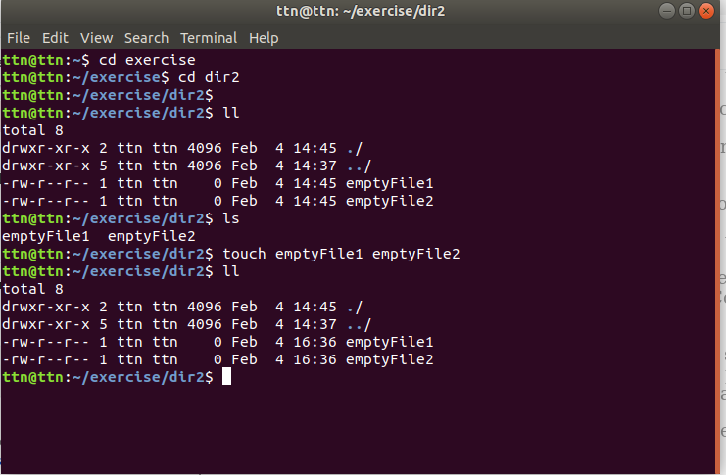

Question 11:Create alias with your name so that it creates a file as "/tmp/aliastesting".

Ans: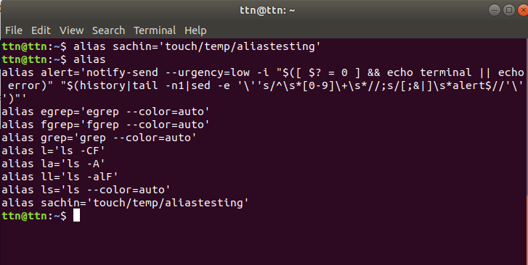

Here firstly i created alias with my name.and after that print all the alias using alias command.

Question 12: Edit ~/.bashrc file such that when you change to "test" user it should clear the screen and print "Welcome".

Ans: Here firstly bashrc file is edited using vim editor.and write a welcome note Welcome Sachin.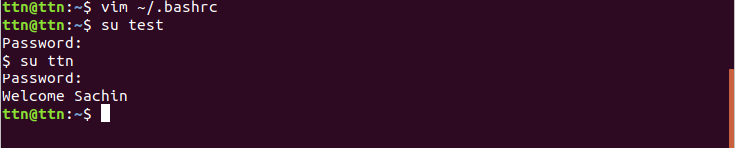 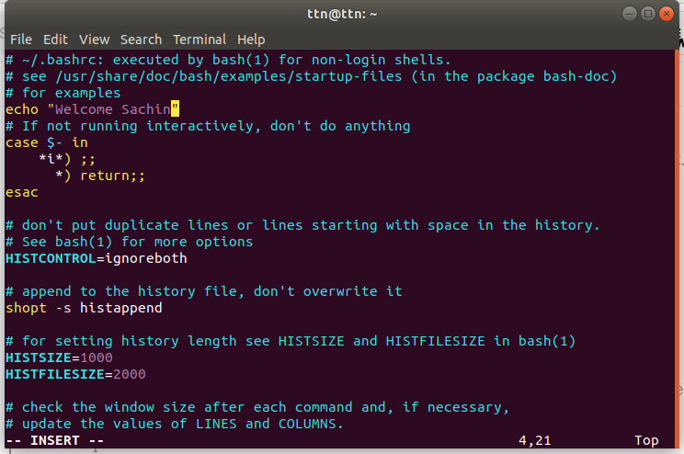

Question 13: Install “zip” package.

Ans: To install any package ,*sudo apt-get install filename* command is used. Since here zip package is already installed that's why it only tries to update . 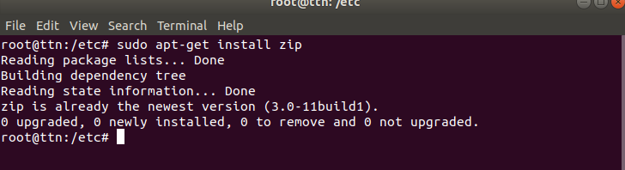

Question 14: Compress "output" and "password_backup" files into a tar ball. List the files present inside the tar created.

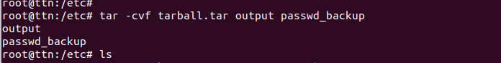

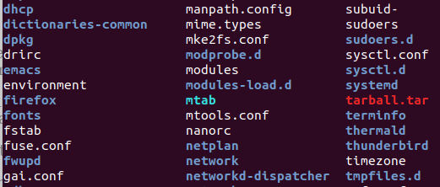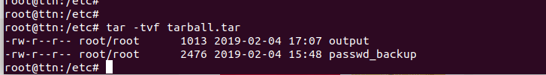

In the first image a tar file is created using command *tar*.

The syntax for tar command is :

Syntax: *tar -cvf output_filename file_1 file_2*

In the second image created tar file is shown in directory.

In the third image all the file shown which was compressed inside .tar file.

Question 15. scp this file to test user.

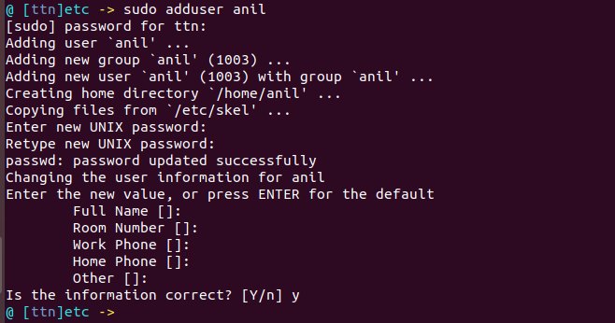



Question 16. Unzip this tar bar by logging into the remote server.

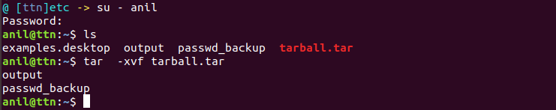

Question 17: Download any image from web and move to desktop.

Ans:-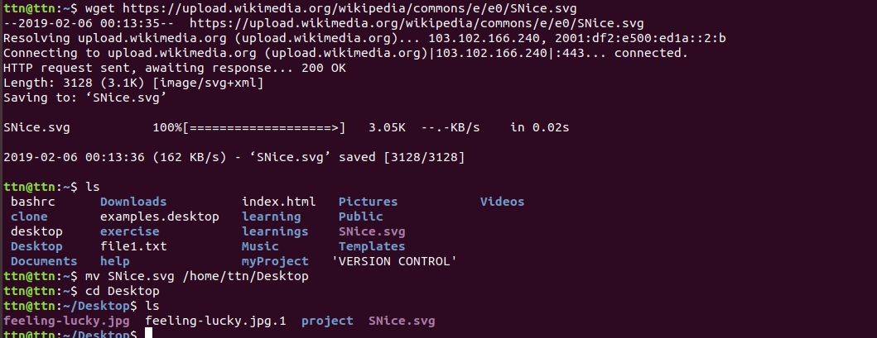

Question 18: How to get help of commands usages.

Ans: To get help for any command --help command is used.

Syntax: *command_name --help*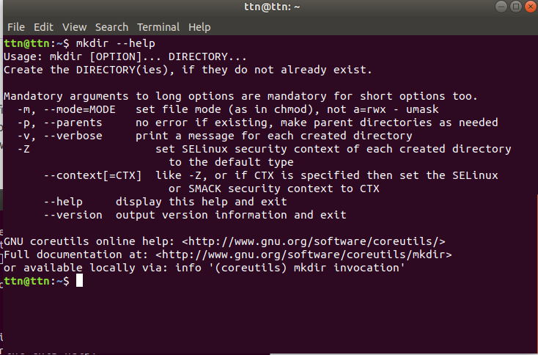

Question 19: Create a symlink of /etc/services into /tmp/ports-info.

Ans: To create symlink *ln -s command is used.*

Here to create symlink of /etc/services into /tmp/ports-info following command is used:

*$ln -s /etc/services /tmp/ports-info*

Question 20: You are appointed as a Software/DevOps Engineer in ABC media services. On your first day you need to troubleshoot a problem. There is a command “xyz” somewhere installed in that linux system. But as a new joinee you do not have any idea about where is that Installed. How can you check that?

Ans: We can check that command using “which” command. Suppose for example we need to find “man command ”so we can find where it installed like :

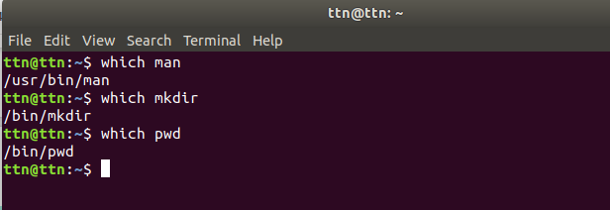

**Which command:** which command search for executables in the directories specified by the environment variable PATH. And if found out, the full pathname of this executable will be printed.

Syntax : *which ls*